The First World War in Italy and Beyond
History, Legacy and Memory (1918–2018)

30 November – 1 December 2018
Italian Institute of Culture, London

Annual Conference of the Association for the Study of Modern Italy

Call for papers and panels

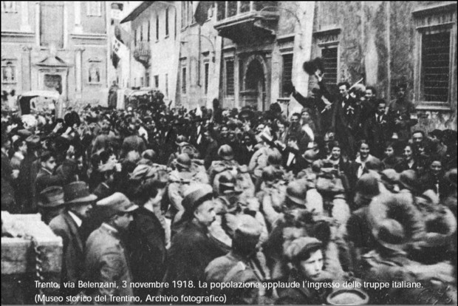

The conference will explore the history, legacy and memory of the First World War in Italy from 1918 to 2018. As the War was one of the formative experiences of the modern Italian nation, the aim is to place the conflict in a longer chronological perspective and to highlight its lasting impact from a range of viewpoints. Drawing on recent innovations in the historiography, the conference will shift focus away from the battlefields towards hitherto neglected areas of study, including the experience of civilians and everyday life, the transition from war to peace, and the post-war climate and reconstruction. It will shed light on how the memory of WWI shaped Italy's national identity and served political ends during the Fascist period and after the Second World War. The intention is also to escape the confines of national historiography by placing Italy in comparative and transnational contexts. Thus, the centenary presents an opportunity to look with fresh eyes at the mark left by the War on the history, politics and society of Italy.

We welcome proposals from scholars working in a variety of disciplines including history, literature, film, politics, anthropology, art, economics, sociology and geography.

Panels might include, but are not limited to:

- The immediate aftermath of WW1 (1918–1922) and the rise of social conflict, political violence and Fascism
- The creation of the League of Nations and the emergence of pacifism, humanitarianism and internationalism
- The experience of veterans in the post-war period
- New historiographical approaches to the study of Italy and WW1
- Global, transnational and comparative perspectives
- Local, regional and national experiences
- Gender, both femininity and masculinity
- Family and societal ties
- Changes to ideas of nationhood, democracy, citizenship and community after WW1
- The legacy of WWI under Fascism
- Parallels between the aftermath of WW1 and the aftermath of WW2
- The material heritage of the War: monuments, memorials and cemeteries
- Italy's commemorations of the centenary in national or transnational contexts

The organizers welcome proposals for individual papers and for panels composed of 3 speakers. They reserve the right to break up and re-structure proposed panels.

Confirmed keynote speakers:

Prof. Gunda Barth-Scalmani (University of Innsbruck)
Author of numerous works on Italian-Austrian relations and the experiences of women during WWI, including Ein Krieg - Zwei Schützengräben, Österreich - Italien und der Erste Weltkrieg in den Dolomiten 1915–1918 (Bozen 2005) and Militärische und zivile Kriegserfahrungen 1914–1918 (Innsbruck, 2010).

Dr. Marco Mondini (University of Padua/Fondazione Bruno Kessler, Trento)
Author of numerous bestselling books on Italy and WW1, including most recently Il Capo. La Grande Guerra del generale Luigi Cadorna (Il Mulino 2017) and La guerra italiana. Partire, raccontare, tornare 1914-18 (Il Mulino 2014). He is a frequent contributor to programmes on Rai Storia, e.g. http://www.raistoria.rai.it/articoli/cadorna-il-capo/32462/default.aspx

Please send an abstract of max. 250 words and a short biography to asmi.conference1918@gmail.com
Abstracts can be both in English and in Italian.
The closing date for receipt of abstracts is 1 June 2018

Accepted speakers will be required to join ASMI, which includes subscription to the journal Modern Italy.

Organising Committee: Selena Daly (University College Dublin), Carlotta Ferrara degli Uberti (University College London), Hannah Malone (Freie Universität Berlin), Martina Salvante (University of Warwick)

